|  |
| --- |
| DataBAse Management System  Address · CDAC Noida  Email · Abhishek.dmrl@gov.in |
|  |

Topics which are going to covered in this training program.

* DMBS
* MySQL
* PostgreSQL

**14/10/2024**

We learnt about to start the mysql through XAMPP server and setup through cmd prompt.

We use some commands to access the xampp server setup and create databases via command prompt and make the tables and operations on the tables.

* Win+R = run dialogue box
* Type cmd and press enter key
* It will open the cmd prompt.
* Type cd\
* Then type cd\xampp
* Then cd\mysql
* Then cd\bin
* Again type my sql it will generate an error
* ERROR 1045 (28000): Access denied for user 'CDAC'@'localhost' (using password: NO)
* After this error we will see that it asking for login through super user and password so will use below command
* C:\xampp\mysql\bin>mysql -u root -p
* Enter password:
* Then again press enter key
* Welcome to the MariaDB monitor. Commands end with ; or \g.
* Your MariaDB connection id is 11
* Server version: 10.4.32-MariaDB mariadb.org binary distribution.
* Copyright (c) 2000, 2018, Oracle, MariaDB Corporation Ab and others.
* Type 'help;' or '\h' for help. Type '\c' to clear the current input statement.
* MariaDB [(none)]> then type command - show databases it will shows all the databases which are available in mysql
* If use want to create a new database, we will use the command in create database new_database-name like cdac
* Then use the command – use cdac for selection of the current databse
* Then use show tables; for looking the existing tables
* Then use create table.

**15/10/2024**

**DBMS**

**What is Database?**

A database is a collection of data. The database is a collection of inter-related data which is use to retrieve, insert and delete the efficiently. It is also used to organize the data in the form of tables, views, schemas, reports, etc.

**Database Languages**

* Data Definition Language
* Data Manipulation Language
* Data Control Language
* Transactional Control Language

**Data Definition Language (DDL)**

DDL is the short name for Data Definition Language, which deals with database schemas and descriptions, of how the data should reside in the database.

* **CREATE:** to create a database and its objects like (table, index, views, store procedure, function, and triggers)
* **ALTER:** alters the structure of the existing database
* **DROP:** delete objects from the database
* **TRUNCATE:** remove all records from a table, including all spaces allocated for the records are removed
* **COMMENT:** add comments to the data dictionary
* **RENAME:** rename an object

**Data Manipulation Language (DML)**

**DML** is the short name for Data Manipulation Language which deals with data manipulation and includes most common SQL statements such SELECT, INSERT, UPDATE, DELETE, etc., and it is used to store, modify, retrieve, delete and update data in a database. **Data query language(DQL)** is the subset of “Data Manipulation Language”. The most common command of DQL is **SELECT** statement. SELECT statement help on retrieving the data from the table without changing anything in the table.

* **SELECT:** retrieve data from a database
* **INSERT:** insert data into a table
* **UPDATE:** updates existing data within a table
* **DELETE:** Delete all records from a database table
* **MERGE:** UPSERT operation (insert or update)
* **CALL:** call a PL/SQL or Java subprogram
* **EXPLAIN PLAN:** interpretation of the data access path
* **LOCK TABLE:** concurrency Control

**Data Control Language (DCL)**

**DCL** is short for Data Control Language which acts as an access specifier to the database. (basically to grant and revoke permissions to users in the database

* **GRANT:** grant permissions to the user for running DML (SELECT, INSERT, DELETE,…) commands on the table
* **REVOKE:** revoke permissions to the user for running DML (SELECT, INSERT, DELETE,…) command on the specified table

**Transactional Control Language (TCL)**

**TCL** is short for Transactional Control Language which acts as a manager for all types of transactional data and all transactions. Some of the command of TCL are

* **Roll Back:** Used to cancel or Undo changes made in the database
* **Commit:** It is used to apply or save changes in the database
* **Save Point:** It is used to save the data on the temporary basis in the database

**Data Query Language (DQL)**

**Data query language(DQL)** is the subset of **“Data Manipulation Language”**. The most common command of DQL is 1the **SELECT statement**. SELECT statement helps us in retrieving the data from the table without changing anything or modifying the table. DQL is very important for retrieval of essential data from a database.

**Characteristics of DBMS**

* It uses the **digital repository** established on a server to store and manage the information.
* It can provide a **clear and logical view of the process** the manipulates data.
* DBMS contains **automatic backup and recovery** procedures.
* It contains **ACID properties** which maintain data in a healthy state in case of failure.
* It can reduce the **complex relationship** between data.
* It used to support **manipulation and processing** of data.
* It is used to provide **security of data**.
* It can view the database from **different viewpoints** according to the requirements of the user.

**Advantages of DBMS:**

* Controls database redundancy
* Data Sharing
* Easily Maintenance
* Reduce time

Extra Layer of Security

* Backup
* Multiple user interface

**ACID Properties:** A transaction is a single logical unit of work that accesses & possibly modifies the contents of a database. Transactions access data using read and write operations.

In order to maintain consistency in a database, before & after the transaction, certain properties are followed. These are called ACID properties.

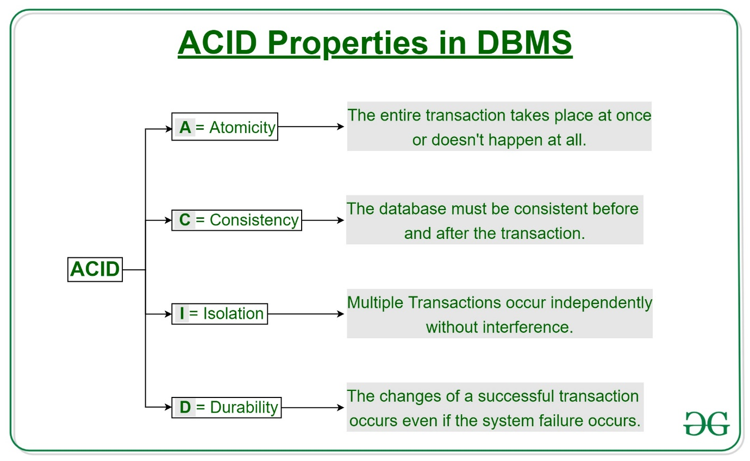

**Relational Model:** Relational DBMS is the most widely used DBMS model because it is one of the easiest. This model is based on normalizing data in the rows and columns of the tables. Relational model stored in a fixed structures and manipulated using SQL.

**NoSQL Databases:** Non-SQL/Not only SQL is a type of database that is used for storing a wide range of data sets. It is not a relational database as it stores data only in tabular form but in several different ways. It came into existence when the demand for building modern applications increased. Thus, NoSQL presented a wide verity of database technologies in response to the demands.

**Difference between SQL & NoSQL**

|  |  |
| --- | --- |
| **SQL** | **NoSQL** |
| SQL Database is a relational. | NoSQL databases are non-relational |
| These databases have fixed are static or predefined schema. | They have dynamic schema for unstructured data. |
| It was developed in the 1970s to deal with issues with flat file storage. | Developed in the late 2000s to overcome issues and limitations of SQL databases. |
| SQL database are table based. | NoSQL databases are document, key-value, graph, or wide-column stories. |
| SQL databases are better for multi row transaction. | NoSQL is better for unstructured data like documents or JSON. |
| **Examples**: [MySQL](https://www.geeksforgeeks.org/mysql-common-mysql-queries/), [PostgreSQL](https://www.geeksforgeeks.org/what-is-postgresql-introduction/), Oracle, MS-SQL Server, etc | **Examples**: [MongoDB](https://www.geeksforgeeks.org/mongodb-tutorial/), HBase, Neo4j, Cassandra, etc |